

Department Subject Academic Year Faculty Name

STUDENT CASE STUDY EXECUTION REPORT
FED
DSA-2
I-III Semester (2025-26)

Student Name Roll Number Branch
Course Outcome

1. CO1 – Trees & Balanced Search Structures

Case Study Topic: Event Registration Management using AVL Tree

Work Done Summary:
In this case study, we implemented an AVL Tree to manage participant registrations for events in EventSphere.
Each participant is stored using ParticipantID as the key.
The AVL Tree keeps the database balanced, enabling fast insertion, deletion, and search operations even when many users register simultaneously.

Implementation Details:
- Created AVL Tree nodes with ParticipantID and participant name.
- Inserted participant registrations into the tree.
- Performed balancing using LL, RR, LR, and RL rotations.
- Searched participants using ParticipantID.
- Deleted cancelled registrations.
- Used in-order traversal to display participants in sorted order.

Result / Output:

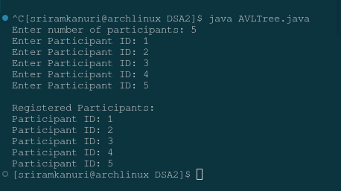

AVL Tree maintained balanced registration records efficiently.
Searching and updating participant details became faster compared to linear search.

Time Complexity:
- Insert: O(log n)
- Delete: O(log n)
- Search: O(log n)

2. CO2 – Multiway Trees & Range Query Structures

Case Study Topic: Event Date Query using B+ Tree

Work Done Summary:
Implemented a B+ Tree to index event schedules based on event dates.
This allows EventSphere to quickly retrieve events occurring within a date range.

Implementation Details:
- Created B+ Tree nodes.
- Inserted events with Event Date.
- Stored records in leaf nodes.
- Linked leaf nodes for sequential access.
- Performed range query for selected dates.
- Displayed matching event list.

Result / Output:

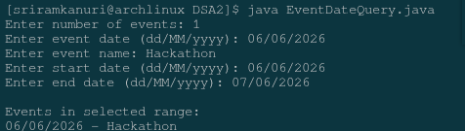

System quickly returned all events scheduled between given dates.

Time Complexity:
- Insert: O(log n)
- Search: O(log n)
- Range Query: O(log n + k)

3. CO3 – Graph Algorithms for Event Networks

Case Study Topic: Venue Accessibility Analysis using BFS

Work Done Summary:
Used Breadth First Search (BFS) to analyze accessibility between event venues connected through transportation routes.

Implementation Details:
- Represented venues as graph vertices.
- Added routes as edges.
- Started BFS from main venue.
- Visited all reachable venues level by level.
- Stored visited nodes.
- Displayed accessibility order.

Result / Output:

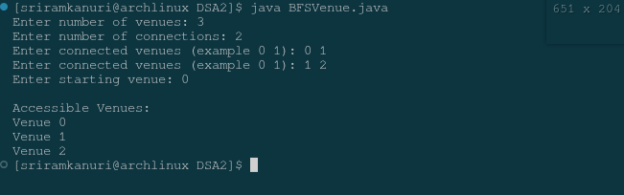

BFS successfully found all reachable venues and nearest connected locations.

Time Complexity:
- BFS: O(V + E)

4. CO4 – Shortest Path Optimization

Case Study Topic: Shortest Route to Venue using Dijkstra’s Algorithm

Work Done Summary:
Implemented Dijkstra’s Algorithm to calculate shortest travel distance between user location and event venue.

Implementation Details:
- Represented venues and roads as weighted graph.
- Assigned distances to edges.
- Started from source node.
- Updated shortest distances.
- Selected nearest node repeatedly.
- Displayed shortest route.

Result / Output:

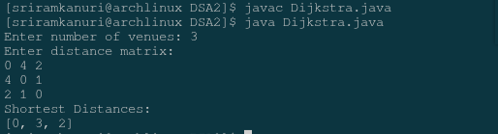

Users received the shortest path to venue quickly.

Time Complexity:
- Dijkstra: O((V+E) log V)

5. CO5 – Advanced Sorting & Data Ranking

Case Study Topic: Event Popularity Ranking using Quick Sort

Work Done Summary:
Used Quick Sort to rank events by number of registrations.

Implementation Details:
- Stored event names and registration counts.
- Selected pivot.
- Partitioned based on popularity.
- Recursively sorted subarrays.
- Displayed ranking.

Result / Output:

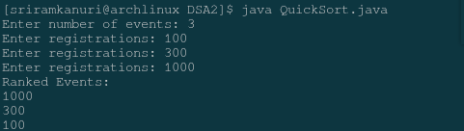

Most popular events were shown first.

Time Complexity:
- Average: O(n log n)
- Worst: O(n²)

6. CO6 – Greedy Algorithms & Dynamic Programming

Case Study Topic: Event Session Scheduling using Activity Selection

Work Done Summary:
Implemented Activity Selection algorithm to schedule maximum number of sessions without time overlap.

Implementation Details:
- Stored session start/end times.
- Sorted by finish time.
- Selected earliest finishing session.
- Compared next session.
- Added compatible sessions.
- Displayed final schedule.

Result / Output:

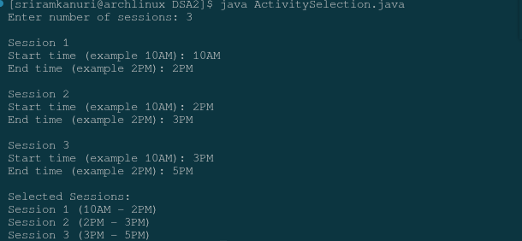

Maximum sessions were scheduled efficiently.

Time Complexity:
- Sorting: O(n log n)
- Selection: O(n)

GitHub Link:

